H.T No
Regulations:
A18

Sreenidhi Institute of Science and Technology
(An Autonomous Institution)
Code No: 7K201 Date: 14-July-2021 (AN)

B.Tech I-Year II- Semester External Examination, July-2021 (Supplementary)
ENGINEERING MECHANICS FOR CIVIL ENGINEERING (CIVIL)

Time: 3 Hours Max.Marks:70

Note: a) No additional answer sheets will be provided.
b) All sub-parts of a question must be answered at one place only, otherwise it will not be valued.
c) Missing data can be assumed suitably.

ANSWER ANY 5 OUT OF 8 QUESTIONS. EACH QUESTION CARRIES 14 MARKS.

Bloom's Cognitive Levels of Learning (BCLL)

Remember | L1 | Apply | L3 | Evaluate | L5
Understand | L2 | Analyze | L4 | Create | L6

 |  |  | BCLL | CO(s) | Marks
1. |  | Two cylinders A and B rest in a horizontal channel as shown in fig below. The cylinder A has a weight of 1000 N and radius of 9.0 cm. The cylinder B has a weight of 400 N and a radius of 5.0 cm. The channel is 18.0 cm wide at the bottom with one side vertical. The other side is inclined at an angle 60⁰ with the horizontal. Find the reactions at points L, N and P  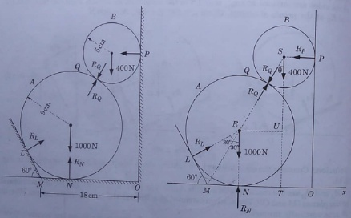 | L2 | CO1 | [14M]
2. |  | Using the method of joints, find the axial forces in all the members of a truss with the loading shown in below figure  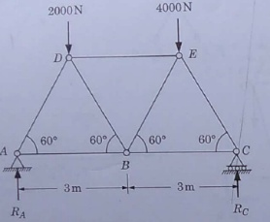 | L3 | CO2 | [14M]
3. |  | Calculate the moment of inertia given I-section shown in figure 3, about point 'O'.  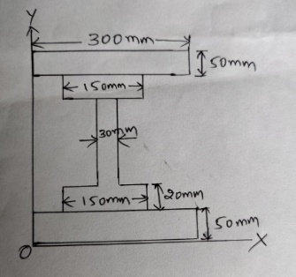 | L4 | CO3 | [14M]
4. |  | A hemispherical cup of radius r and having its center of gravity at C rests on the top of a spherical surface of radius R shown in below fig. Establish the criterion of stability of the cup in the position shown assuming that there is sufficient friction to prevent slipping.  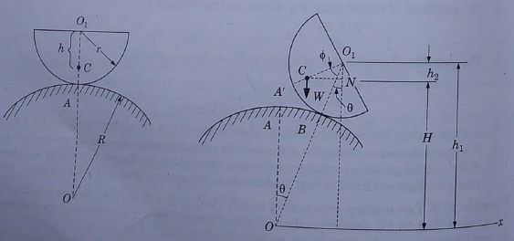 | L4 | CO4 | [14M]
5. |  | A football is kicked with a velocity of 20 m/s at an angle of 450 with the horizontal  - Find the time taken by the ball to strike the ground  - Find the maximum height it reaches  - How far away from the kick does it hit the ground  - With what minimum velocity that the footballer should run to catch the football before it touches the ground? Take g = 10 m/s². | L4 | CO5 | [14M]
6. | a) | Motion of particle is given as x= t³-3t²-9t+12. Determine the position, velocity and acceleration of particle when the time is 2sec | L2 | CO6 | [7M]
 | b) | A gun of mass 3000kg fires horizontally and shell of mass 50kg with a velocity 300m/s. what is the velocity which gun will recoiled and also determine the uniform force required to stop the gun at a distance of 0.6meters. | L2 | CO6 | [7M]
7. |  | Determine moment of inertia of the shaded area as shown in below figure w.r.t. x-axis and y-axis by direct integration  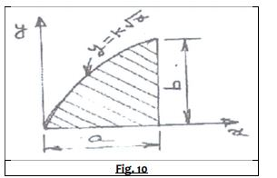 | L3 | CO1 | [14M]
8. |  | A horizontal bar 1 m long and of negligible weight rests on rough inclined planes shown in below fig. If the angle of friction is 15⁰, determine the minimum value of x at which the load Q = 200N may be applied before slipping impends.  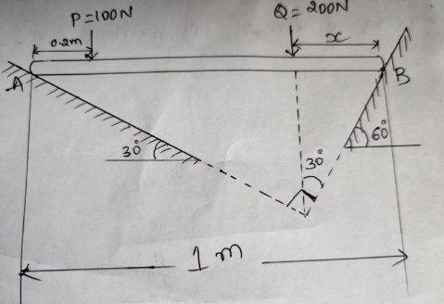 | L4 | CO4 | [14M]
-- 00 -- 00 –

